Understanding Russian Weightlifting Methods
Making sense of the mysterious Eastern Bloc workouts
by Charles Poliquin
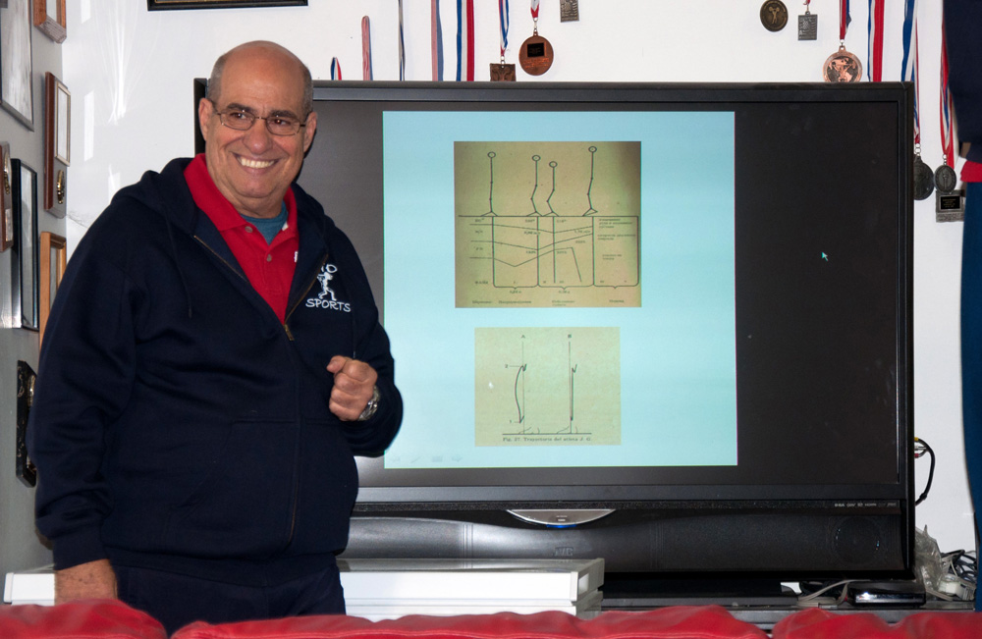
Dr. Alfredo Herrera, a renowned weightlifting coach who holds a Doctor of Science degree from the State Central Institute of Physical Culture in Moscow, Russia, holds seminars in the US on the Russian weightlifting system.
The Russians have been a dominant force in weightlifting for over half a century. Yes, they have had their challengers, notably the Bulgarians in the ’70s and ’80s and more recently the Chinese, but the Russians have always fielded strong teams and have consistently produced Olympic champions, world champions and world record holders. Coaches from other countries have sought to learn from the Russians, but it’s been a challenge because much of the material has been, as Bill Murray and Scarlett Johansson might say, “lost in translation.”
If you Google long enough, you will find numerous articles and textbooks written by accomplished Russian weightlifting coaches translated into English. Unfortunately, some of these translations were not very well done – and many articles, rumor has it, were simply delegated to college students to translate for extra credit. Nevertheless, there is enough material available that if you study carefully and look for consistencies among authors, you should be able to figure out general trends. As such, I’d like to give you a primer on how to study these Russian weightlifting articles and books.
First, consider that it is best to start with the textbooks rather than individual articles. You’ll find that the individual articles often contain very specialized material and focus on just one aspect of training, especially technique – the Russians were fond of analyzing the technique of top lifters, including those from other countries. Let me give you an example.
One article from Russia that has a publishing date of 1986 focused on the clean and jerk technique of Bulgarian weightlifter Alexander Varbanov, specifically his attempt at a world record of 212.5 kilos in the 77-kilo bodyweight class. In the article the following comment appears: “…the athlete was unable to generate sufficient resistance during the amortization part of the “squat under”; consequently, the barbell dropped 25 cm (24 cm for the 210 kgs) and the athlete had to fix it at a (uncharacteristic for him) height of 65 cm (instead of 68 cm) in the squat position. As a result, he relaxes his lower back and lowers his pelvis approximately 3.5 cm more than in the 210 kg lift.” An elite coach may find this information interesting and useful, but such an article is definitely not a good starting point for studying the Russian weightlifting system.

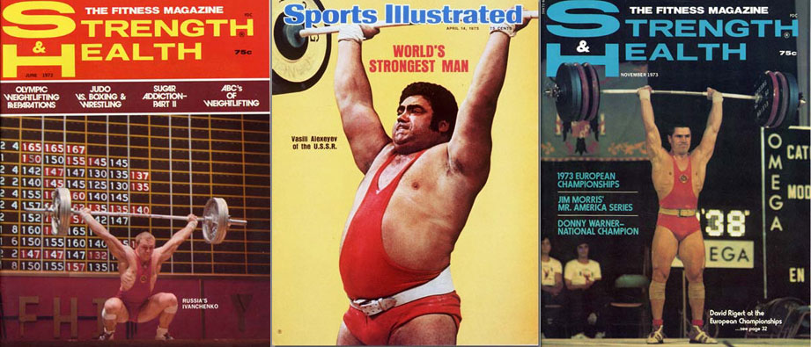
The Russians have been a dominant force in weightlifting since the 1950s, and their champions were frequently featured on magazine covers.

Among the most readable basic textbooks on weightlifting technique and training are those written by Robert A. Roman and Arkady N. Vorobyev; the textbooks written by Alexander S. Medvedyev are a bit more of a challenge (but to be fair, some of the confusion may originate in the translators). Sportivny Press offers several textbooks written by Roman and Medvedyev, and you can purchase Arkady N. Vorobyev’s comprehensive work, A Textbook on Weightlifting, through Amazon.com. After mastering these works, the next step would be to look at the compendiums of articles from various authors in the Weightlifting Yearbooks published by Sportivny Press.
Before you dig in, let me give you a head start by explaining some terminology frequently used by Russian coaches that are not universally recognized, especially in North American countries.
East vs. West: Loading Parameters
In PICP courses I introduce the following loading parameters that should be manipulated to produce optimal training prescriptions: reps, sets, rest intervals, tempo, exercise selection, number of exercises, rate of change of exercises, exercise order and training frequency. In comparison, Russian textbooks often use the following terms (this list is not all-inclusive): volume of load, intensity of load, number of repetitions per set, rest intervals, speed of lifting, regimes of muscular activity, number of exercises per training session, order of performance of the exercises, training frequency, and training zones. Let’s look at each of these phrases in turn.
Volume of Load. This is the total amount of work performed in a specific period, such as a training session or a training week. Usually only lifts at or above 60 percent are recorded, as the lighter weights are considered part of the warm-up. If a lifter performed back squats for 5 sets of 5 reps and used 100 kilos, the volume of that exercise would be 2500 kilos. The Russians have determined precise volume levels for all levels of lifters, for all major lifts used in training, for levels of ability, and also for precise points within the training period. For example, if four workouts are performed in a week, the training volume for a typical week might be divided as follows:
Day 1: 15 percent
Day 2: 23 percent
Day 3: 37 percent
Day 4: 25 percent
In the week prior to a competition, with the fourth day being the competition, a weightlifter would want to have the majority of the training volume at the beginning of the week. This would enable the athlete to be at their peak for the meet. Here is such a distribution:
Day 1: 54 percent
Day 2: 30 percent
Day 3: 16 percent
Intensity of Load. Intensity is defined by how much weight is on the barbell, with 100 percent intensity being the maximum amount of weight used for 1 repetition (i.e., lifting maximal weights). Russians also like to relate intensity to the load by determining the average amount of weight lifted during an exercise, training session or other training cycle. For example, in a training month, the average intensity of load for the snatch leading up to a competition at the end of the month might be distributed as follows:
Week 1: 105 kilos
Week 2: 120 kilos
Week 3: 125 kilos
Week 4: 100 kilos
Average Weekly Intensity: 112.5 kilos
Generally, there is believed to be an optimal average weight for each lift. The snatch might be 77 percent, the clean and jerk 74, pulls might be 90, and back squat 70. These numbers also would vary based upon the level of the athlete.
Number of Repetitions per Set. The Russians believe that the number of reps performed is closely related to the weight used. Three or more reps are associated with an increase in muscle mass, and singles and doubles are associated more with maximal and relative strength. You’ll often find that when a specific intensity is prescribed, it is associated with a repetition range. For example, 1-2 reps, 95-100 percent; 3 reps, 90 percent, 4-5 reps, 80-85 percent.
Rest Intervals. The amount of rest time between sets influences how much weight can be lifted. Says Vorobyev, “The majority of lifters consider it expedient to have rest intervals between exercises with the bar of 2-5 minutes.” Generally, more rest time is required to recover from the clean and jerk than from the snatch. In contrast, the famous Bulgarian weightlifting coach Ivan Abadjiev uses resting heart rate to determine the optimal time to perform another set.
Speed of Lifting. The Russians believe that lifting of maximal weights can be accomplished, as Vorobyev describes it, “only with sufficiently fast and strong contraction of the muscles.” However, there is research by many Russian scientists who have experimented with a variety of lifting tempos.
Regimes of Muscular Activity. This term refers to additional methods of training that are used to produce higher results, such as isometrics or plyometrics. The Russian sport scientist who has done the most pioneering work in plyometrics is Yuri Verkhoshansky. Professor Verkhoshansky came from a background in coaching jumpers in track and field, and then later sought to apply his research on plyometrics to other sports, including weightlifting. Be warned: Much of Verkhoshansky’s work as translated is nearly impossible to understand – you might even think he is making up his own words – but there are some textbooks that explain plyometrics quite well. One is a book that Verkhoshansky co-authored with Dr. Mel Siff called Supertraining, and another is called Science and Practice of Strength Training by Vladimir M. Zatsiorsky and William J. Kraemer (Human Kinetics).
Number of Exercises per Training Session. Generally, Russian coaches believe a weightlifter should perform four to six exercises per training session. The number of sets performed influences this number, e.g., a high volume of training should generally not be combined with a large number of lifts because the quality of the training session would diminish. The way I like to describe this principle is that there is an inverse relationship between sets and reps.
Order of Performance of the Exercises. Russians usually start with the classical lifts (i.e., snatch and clean and jerk) and their assistance exercises, followed by squats. Vorobyev says the optimal order of exercises would be to start with those movements with a “speedy character,” such as a power snatch or power clean. These would be followed by exercises for strength, such as a back squat, and then those exercises with a “slow character,” such as pulls or presses. Using these criteria a workout might be organized as follows:
1. Power Snatch
2. Clean and Jerk
3. Back Squat
4. Seated Military Press
5. Back Extension
Further, Russian coaches often recommend that weightlifters should periodically perform the classical lifts at the end of a training session to develop stamina.
Training Frequency. In the past, lifters would train three times a week. However, this type of training does not produce the results needed to perform at the elite level. Highly qualified lifters who are preparing for a far-off competition might perform up to six training sessions a week, and then as the competition approaches cut down to four days a week to be at peak physical condition. My motto for justifying this practice is “Fatigue masks fitness!”
Training Zones/Zones of Intensity. The Russians like to organize their training into zones of intensity, or training zones. The major zones would be 60-65 percent of 1RM, 70-75, 80-85, 90-95 and 95-100. In looking at a four-week training program, the snatch lift might be organized as follows (note the shift of intensity with the higher-level lifter):
Percent of 1RM: 60-65 70-75 80-85 90-95 100
Low-Level Lifter: 8 17 5 2 1
High-Level Lifter: 5 15 8 4 2
One aspect of intensity is that the Russians often believe that relatively lighter weights are better for developing speed. If an athlete has a big difference between their classical lifts and their squats, such as being able to clean and jerk 100 kilos but squat 200 kilos, that athlete would need to focus more on a relatively lighter intensity of load, such as 70-80 percent. If the athlete’s squat is very close to their classical lifts, then an average intensity of over 80 percent would be appropriate.

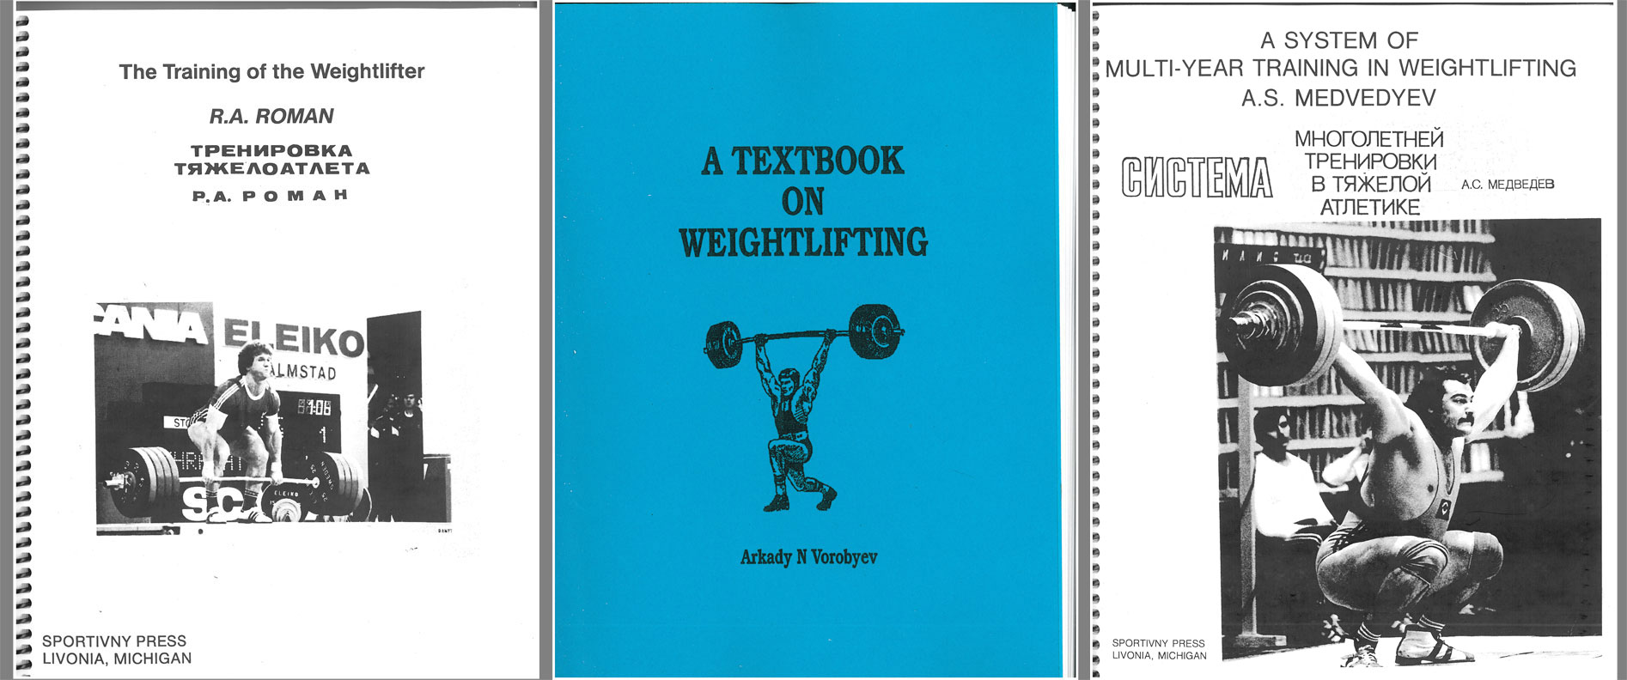
Many Russian weightlifting textbooks are available in English.

Also, consider that using 100 percent intensity as a reference point is a matter of controversy. If you are basing workouts on projected maximum, this is fine; if not, then you should add a category, such as 100-105 percent, as a lifter should always be striving to break records. Further, with this system you are using actual weights, not perceived exertion. Someone using a Bulgarian system may say they are using 100 percent every workout, but in reality they are going as heavy as they can for their current physical condition – we are dealing with mortals, after all.
This system makes for a practical method of comparing training programs. In March 2011 Dr. Alfredo Herrera, a Cuban coach who studied weightlifting in Russia, said the Russians and Bulgarians were relatively equal in terms of training volume, but that the Bulgarians had more lifts in the 95-100 percent zones, while the Russians would have more lifts in the 75-80 percent intensity zone.
Training Cycles. The Russians will often map out training months as much as a year ahead. Some of the names they would use for various training cycles are preparatory, pre-competition and transition – each with their own specific goals. Relating this to a sport such as American football, preparatory would be off-season, pre-competition (or competition) would be in-season, and transition would be post-season. The highest volume of training is usually the preparatory, and the highest intensity would be in the competition phase.
There are many more terms used in Russian weightlifting publications, but these are the basics. Unless you happen to have a talented translator in your back pocket, you’re going to need an “in” to this valuable but unwieldy material. If you make a serious attempt to study these terms, it will be much easier for you to understand the numerous Russian articles and textbooks available to you about the wonderful sport of weightlifting.

